6.3 Commercial Applications of AI
Killamsetti, Tirumala Raju
Foundations of Machine Learning
Instructor: Dr. Longe
April 23, 2026
AI in Action: How Artificial Intelligence is Changing Businesses Today
Artificial Intelligence is no longer just a future idea. It is already being used by many companies to improve how they work, make decisions, and serve customers. In the past one month, there have been several updates that show how AI is becoming a key part of business operations across different industries. In this newsletter, I will focus on three industries where AI is making a strong impact right now: healthcare, finance, and retail. These examples show how AI is not just improving efficiency, but also changing how decisions are made.
Overview of Industries
The three industries I selected are healthcare, finance, and retail. These industries are important because they affect everyday life and handle large amounts of data. AI is helping them become faster, more accurate, and more customer focused.
Healthcare: Smarter Diagnosis and Patient Care
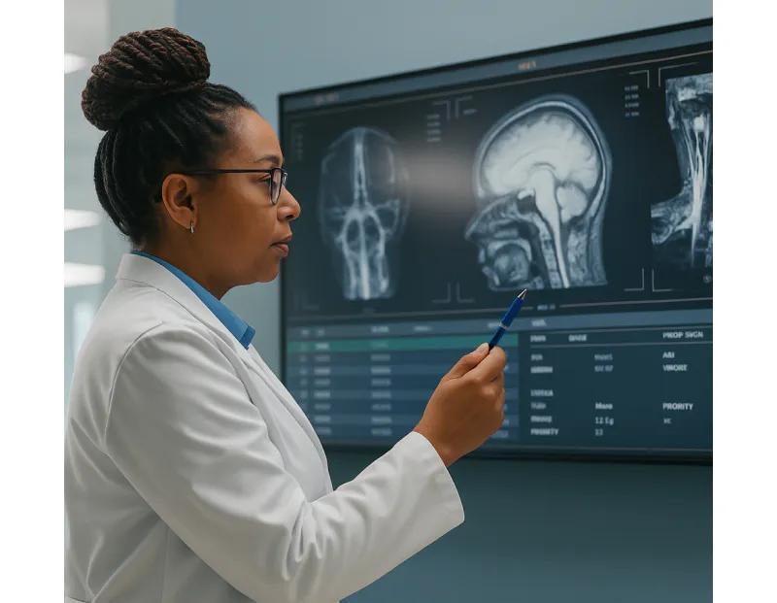 | 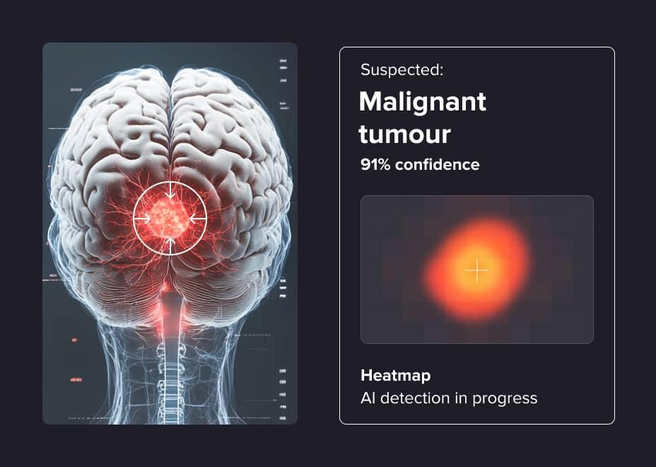
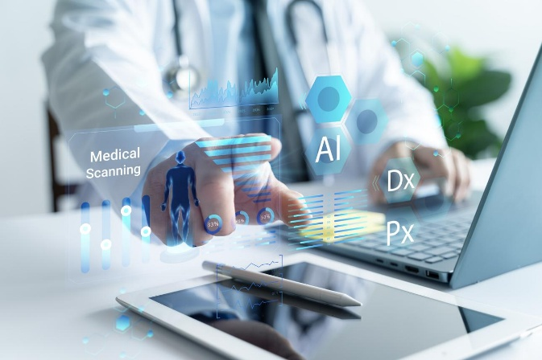
In healthcare, AI is being used to improve diagnosis and patient care. Companies like Google DeepMind are developing AI systems that can analyze medical images and detect diseases earlier than traditional methods.
For example, AI tools are now being used to detect conditions like cancer by analyzing scans. This helps doctors make faster and more accurate decisions. Instead of manually reviewing every image, AI can highlight areas of concern, saving time and reducing human error.
Impact on Business and Decision Making:
Hospitals can handle more patients efficiently and reduce costs. Doctors can focus more on treatment instead of spending too much time on analysis. Decision making becomes more data driven, which improves patient outcomes.
Future Potential:
AI could move from assisting doctors to predicting diseases before they even appear, which would completely change preventive healthcare.
Finance: Better Risk Management and Fraud Detection
 | 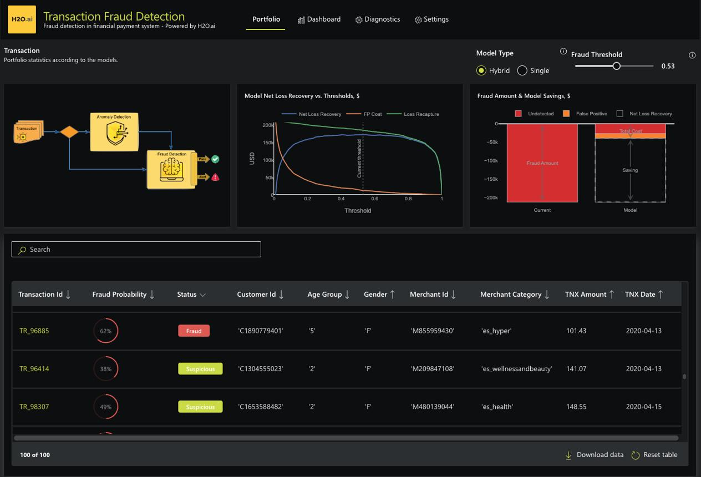
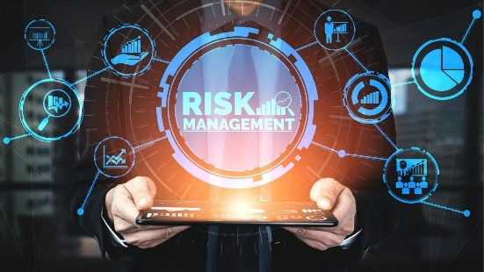
In the finance industry, AI is helping companies detect fraud and manage risks. Companies like JPMorgan Chase are using AI systems to analyze transaction patterns and identify unusual activity.
For example, if a transaction looks different from a user’s normal behavior, AI can flag it immediately. This helps prevent fraud before it happens. AI is also used in loan approvals by analyzing customer data quickly and more accurately than traditional methods.
Impact on Business and Decision Making:
Financial institutions can reduce losses from fraud and make faster decisions on loans and investments. AI improves accuracy and reduces manual work.
Future Potential:
AI may eventually provide fully automated financial advice, helping customers make better investment decisions in real time.
Retail: Personalized Customer Experience
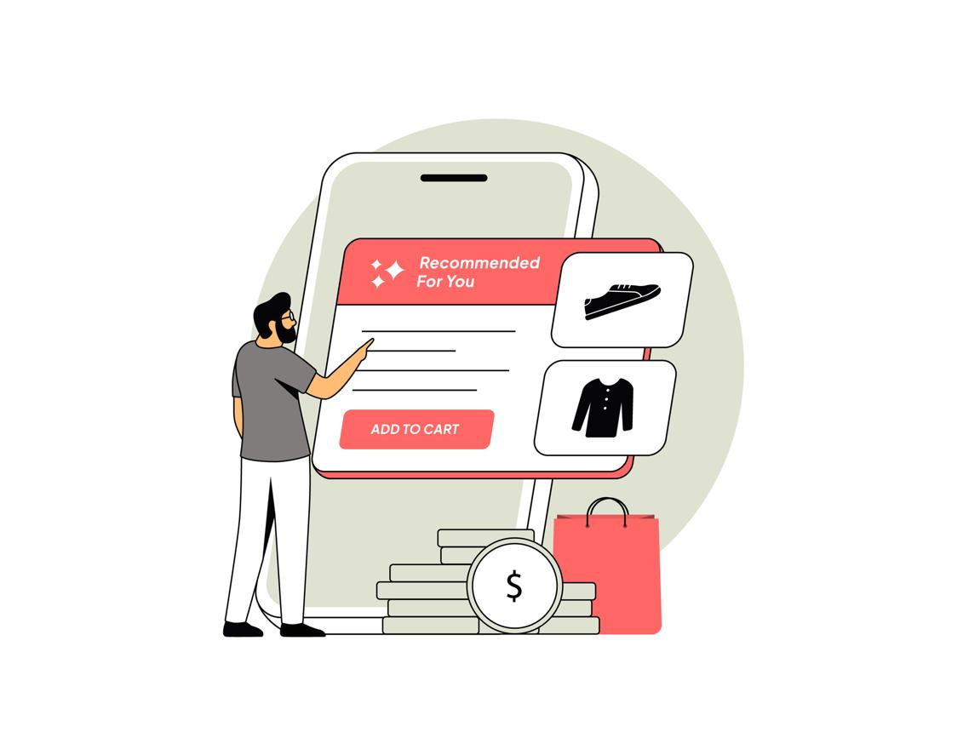 | 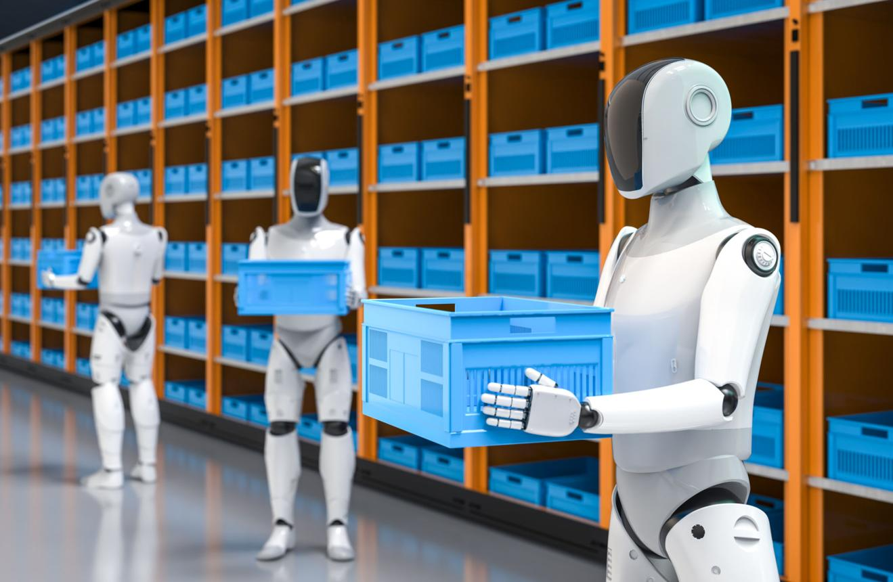

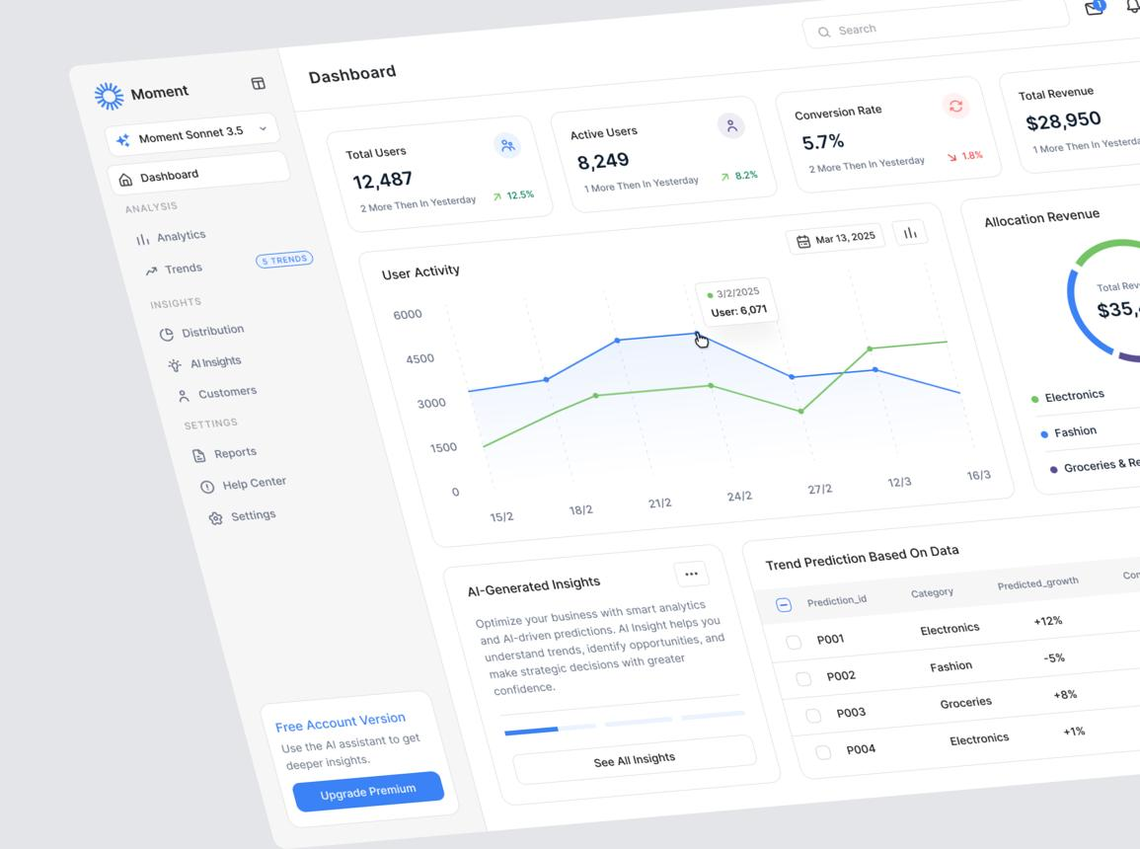

In retail, AI is changing how companies interact with customers. Companies like Amazon use AI to recommend products based on user behavior and preferences.
For example, when customers shop online, AI suggests products they are more likely to buy. This increases sales and improves customer satisfaction. AI is also used to manage inventory by predicting demand.
Impact on Business and Decision Making:
Retailers can better understand customer needs and adjust their strategies. Decisions about pricing, stock, and marketing are now based on data instead of guesswork.
Future Potential:
Retail could become fully personalized, where every customer experiences a unique shopping journey based on their preferences.
Visual Summary of AI Impact Across Industries
Healthcare → Faster Diagnosis → Better Patient Outcomes
Finance → Fraud Detection → Safer Transactions
Retail → Personalization → Higher Customer Satisfaction
Conclusion
These examples show that AI is already transforming businesses in different industries. It is helping companies work faster, make better decisions, and improve customer experiences. However, the real value of AI is not just in automation, but in how it changes decision making. Businesses are moving from intuition based decisions to data driven strategies.
Looking deeper, I think the biggest shift is not just technological, but strategic. AI is becoming part of the core business model, not just a support tool. Companies that understand how to combine human judgment with AI insights will have a strong advantage. At the same time, there are challenges like data privacy, ethical concerns, and over dependence on AI systems. So the future of AI in business will depend not only on innovation, but also on responsible use. In the end, success will come from balancing efficiency with trust, and technology with human values.
AI Tool Disclosure
This newsletter was created with the assistance of ChatGPT to help organize ideas and structure the content. The analysis and final writing reflect my own understanding of the topic.

